TASK 2: Access and Print the Element at a Given Index in an Array
Aim:
To write a Java program to access and print the element at a given index in an array.
Algorithm:
- Start the program.
- Declare and initialize an integer array.
- Read the index value from the user.
- Check whether the entered index is within the valid range.
- If the index is valid, display the corresponding array element.
- Otherwise, display "Invalid Index".
- Stop the program.
Program:
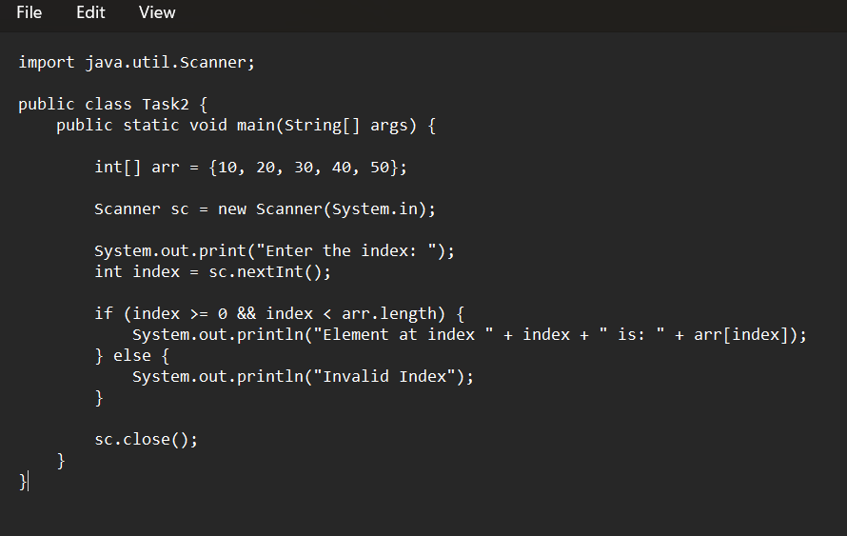Output:
Enter the index: 3
Element at index 3 is: 40
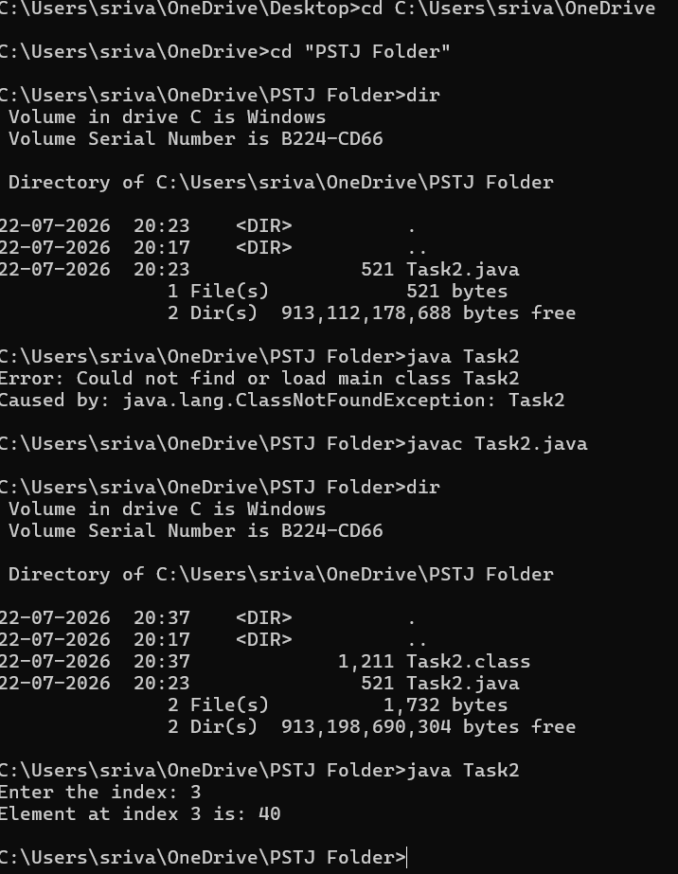

Result:
Thus, the Java program to access and print the element at a given index in an array was executed successfully.

TASK 3: Iterate Over an Array and Print All Elements
Aim:
To write a Java program to iterate over an array and print all the elements of an array.
Algorithm:
- Start the program.
- Declare and initialize an integer array.
- Use a for loop to traverse the array.
- Print each element of the array.
- Stop the program.
Program:
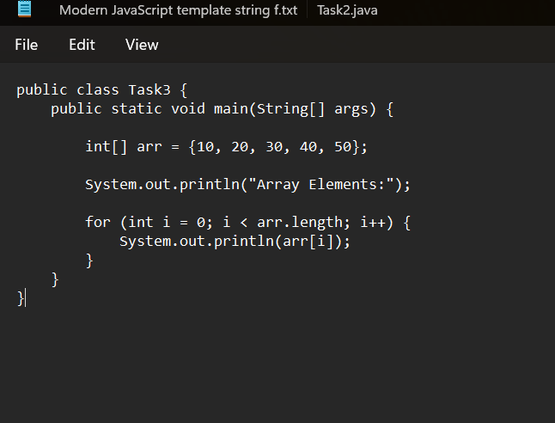
Output:
Array Elements:
10
20
30
40
50

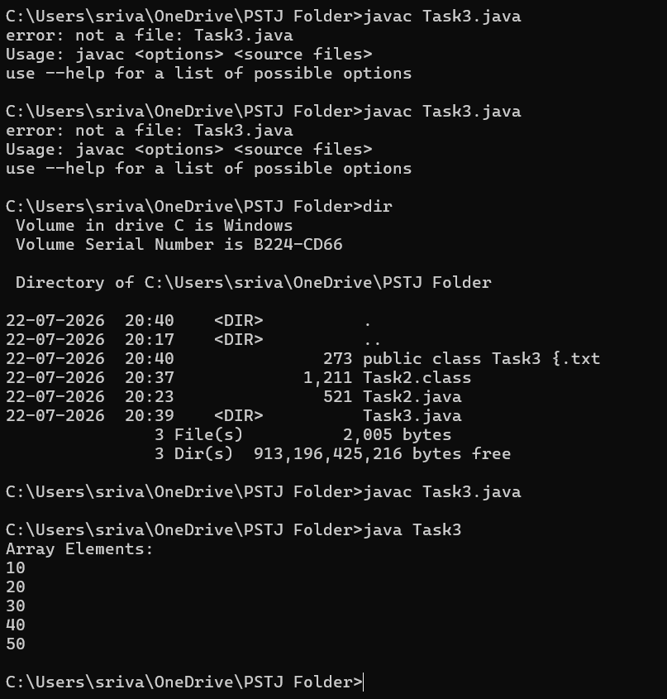
Result:
Thus, the Java program to iterate over an array and print all the elements of an array was executed successfully.

TASK 4: Find the Maximum Element in an Array of n Integers
Aim:
To write a Java program to find the maximum element present in an array of n integers.
Algorithm:
- Start the program.
- Declare and initialize an integer array.
- Assume the first element of the array as the maximum element.
- Traverse through the array using a loop.
- Compare each element with the current maximum value.
- If an element is greater than the maximum value, update the maximum value.
- Print the maximum element.
- Stop the program.
Program (Task4.java)
import java.util.Scanner;

public class Task4 {
public static void main(String[] args) {

Scanner sc = new Scanner(System.in);

System.out.print("Enter the number of elements: ");
int n = sc.nextInt();

int[] arr = new int[n];

System.out.println("Enter the array elements:");

for (int i = 0; i < n; i++) {
arr[i] = sc.nextInt();
}

int max = arr[0];

for (int i = 1; i < n; i++) {
if (arr[i] > max) {
max = arr[i];
}
}

System.out.println("Maximum element in the array is: " + max);

sc.close();
}
}

Output:
Example:
Enter the number of elements: 5
Enter the array elements:
12
45
7
89
23
Maximum element in the array is: 89
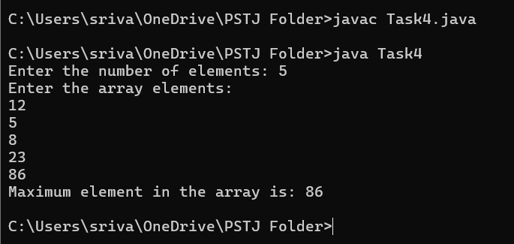
Result:
Thus, the Java program to find the maximum element in an array of n integers was executed successfully.

TASK 5: Find the Minimum Element in an Array of n Integers
Aim:
To write a Java program to find the minimum element present in an array of n integers.
Algorithm:
- Start the program.
- Declare and initialize an integer array.
- Assume the first element of the array as the minimum element.
- Traverse through the array using a loop.
- Compare each element with the current minimum value.
- If an element is smaller than the minimum value, update the minimum value.
- Print the minimum element.
- Stop the program.
Program (Task5.java):
import java.util.Scanner;

public class Task5 {
public static void main(String[] args) {

Scanner sc = new Scanner(System.in);

System.out.print("Enter the number of elements: ");
int n = sc.nextInt();

int[] arr = new int[n];

System.out.println("Enter the array elements:");

for (int i = 0; i < n; i++) {
arr[i] = sc.nextInt();
}

int min = arr[0];

for (int i = 1; i < n; i++) {
if (arr[i] < min) {
min = arr[i];
}
}

System.out.println("Minimum element in the array is: " + min);

sc.close();
}
}
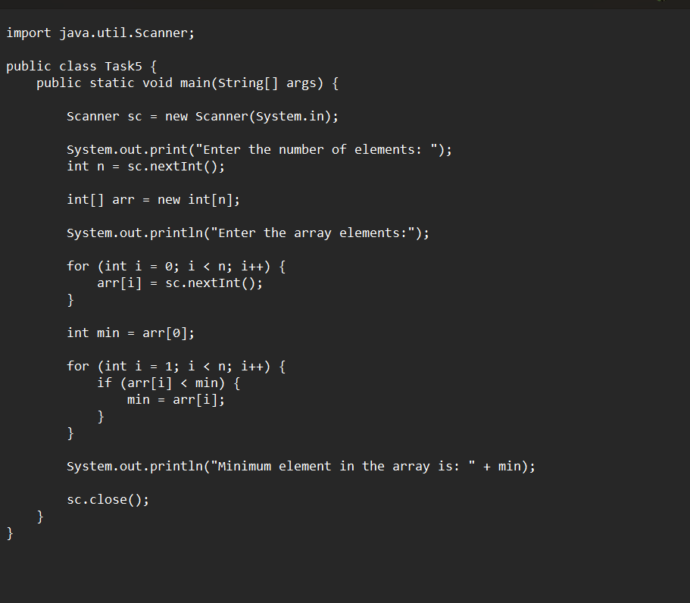

Output:
Example:
Enter the number of elements: 5
Enter the array elements:
12
45
7
89
23
Minimum element in the array is: 7
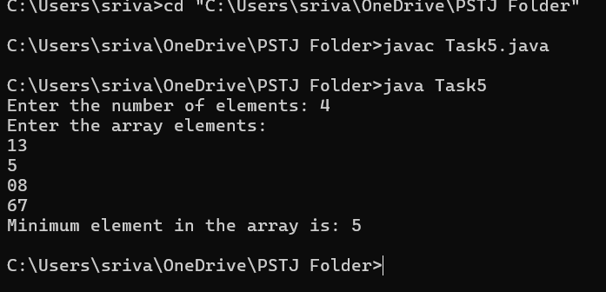

Result:
Thus, the Java program to find the minimum element in an array of n integers was executed successfully.

